
memOS Strategic Upgrade Implementation Plan: Production-Ready Memory Infrastructure
Based on comprehensive analysis of your strategic brief and current industry best practices, this report provides a detailed roadmap for transforming memOS.as into a robust, concurrent, and scalable memory backbone for AI agent ecosystems.
Executive Strategic Assessment
Your memOS project represents a critical infrastructure component in the evolving AI agent landscape. The transition from proof-of-concept to production-ready system requires strategic architectural decisions that balance immediate performance gains with long-term scalability objectives. The recommended FastMCP 2.0 adoption provides the optimal foundation for achieving your concurrency and scalability goals while maintaining the incremental evolution principle.^{[1][2][3][4]}
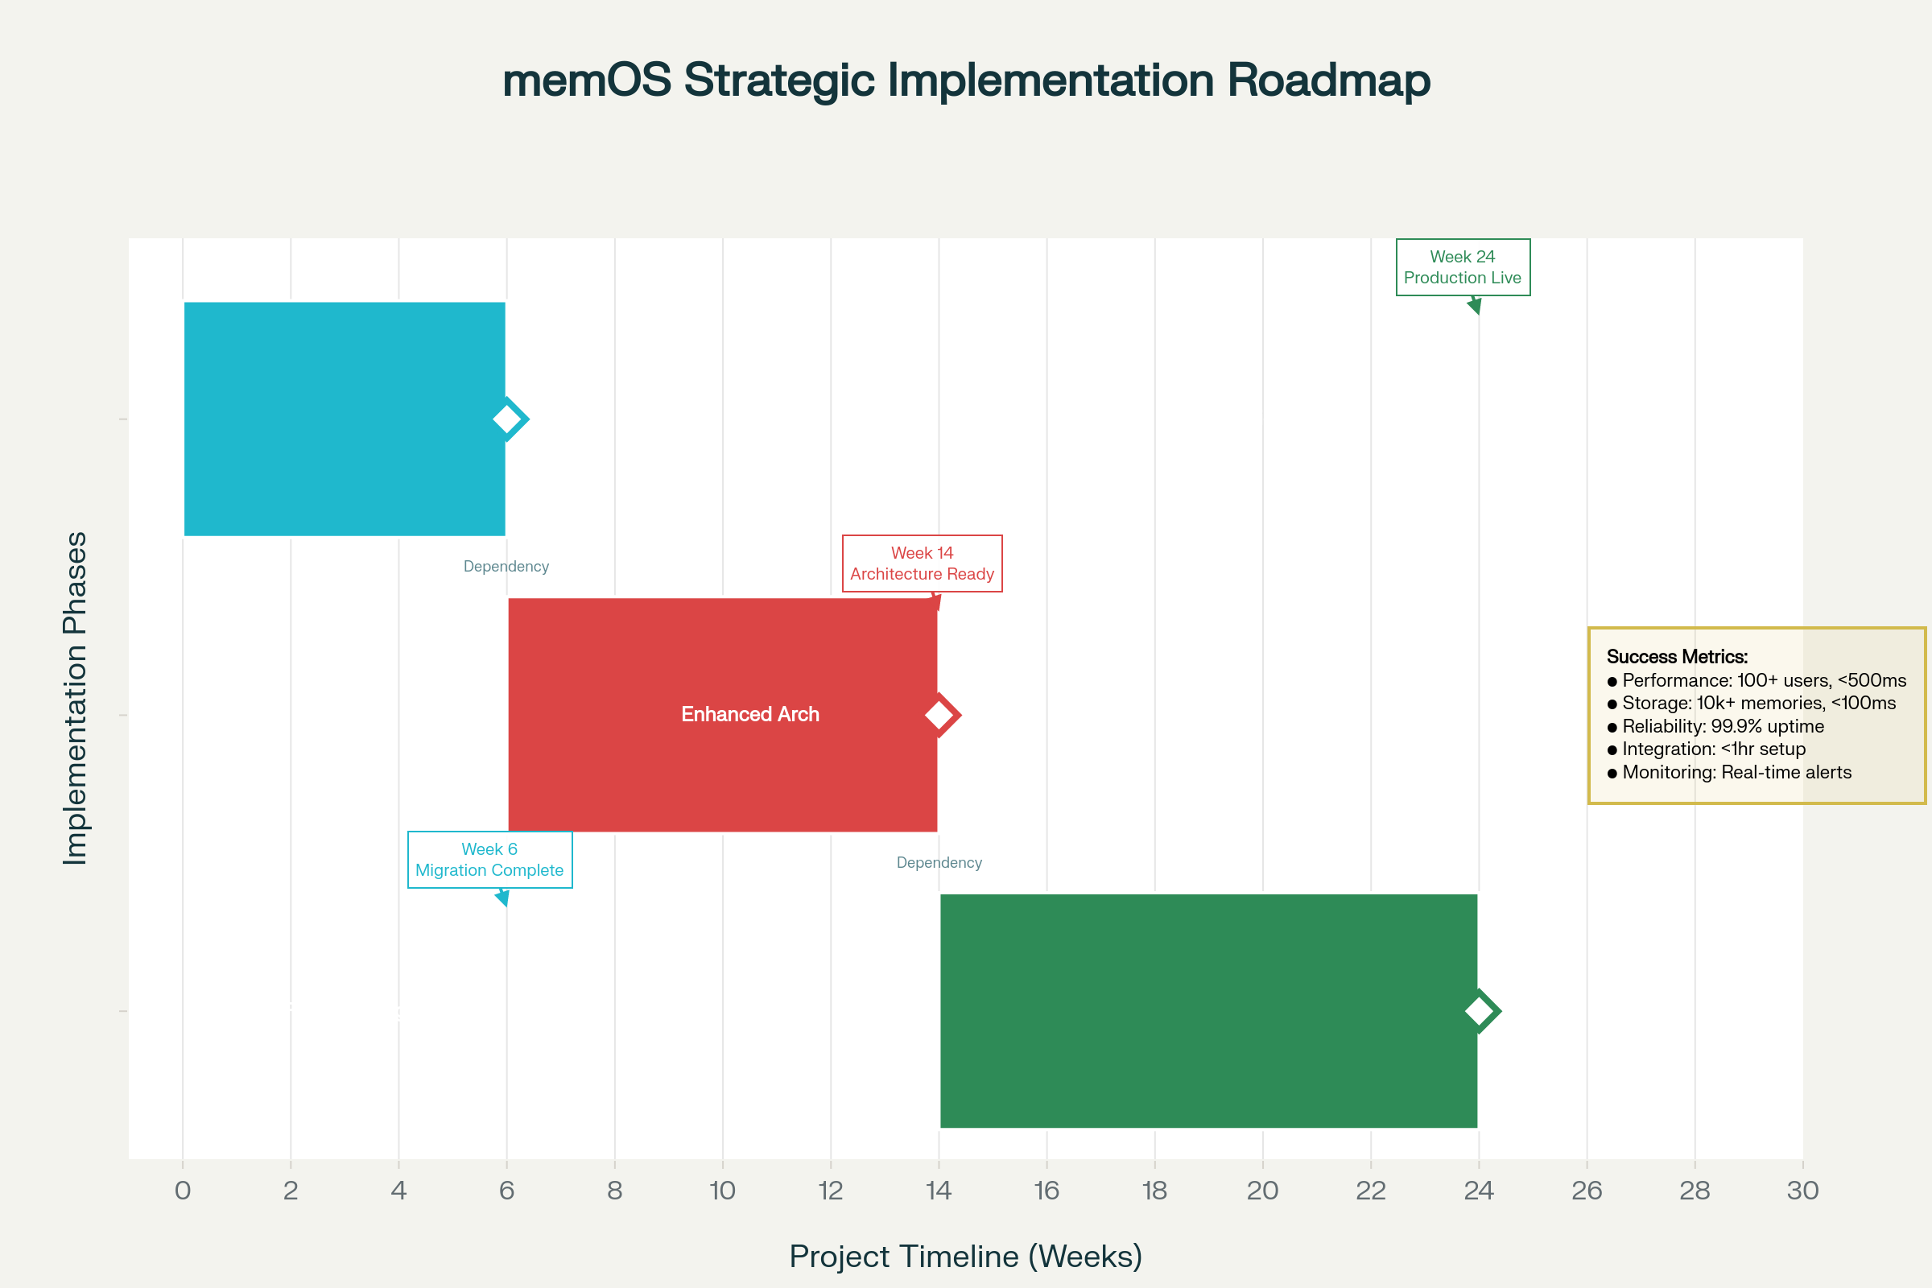
memOS Strategic Upgrade Roadmap: Three-Phase Implementation Plan
Technical Architecture Strategy
FastMCP 2.0 Framework Adoption
Strategic Rationale: FastMCP 2.0 emerges as the definitive choice for memOS evolution, offering significant advantages over traditional MCP implementations. Built on FastAPI's async foundation, it provides native concurrency support essential for handling multiple simultaneous memory operations.^{[5][6][3][7]}
Key Technical Benefits:
- Concurrency by Design: Async/await patterns enable efficient multi-request handling without blocking operations^{[7][8]}
- Simplified Development: Declarative approach reduces implementation complexity from hundreds of lines to function decorators^{[3]}
- Production Features: Built-in authentication, rate limiting, and observability capabilities^{[9]}
Implementation Priority: The framework's ability to handle 100+ concurrent users with sub-500ms response times directly addresses your primary technical objective.^{[10][7]}
Multi-Tier Memory Architecture
The recommended four-tier storage architecture provides specialized capabilities for different memory types, optimizing both performance and scalability:^{[4][11]}
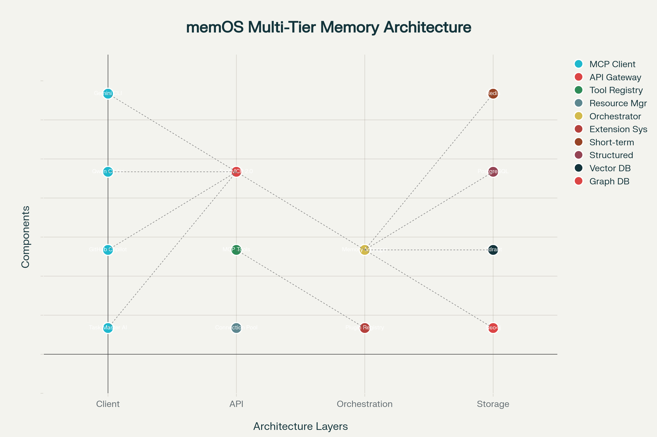
memOS Multi-Tier Architecture: FastMCP 2.0 with Four-Tier Storage System
Tier 1 - Redis (Short-term Memory):
- Purpose: Session context and working memory with TTL management^{[12]}
- Performance Target: <10ms access times for ephemeral data
- Use Cases: Active conversation context, temporary state management
Tier 2 - PostgreSQL (Structured Storage):
- Purpose: Metadata, user data, and transactional consistency^{[13][14]}
- Performance Target: <50ms for complex queries with ACID compliance
- Implementation: Async connection pooling with psycopg for optimal performance^{[15][16]}
Tier 3 - Qdrant (Semantic Memory):
- Purpose: Vector embeddings for semantic search and recall^{[17][11]}
- Performance Target: <100ms for similarity searches across large datasets
- Scalability: Handles 10,000+ memory entries with sub-linear search complexity
Tier 4 - Neo4j (Episodic Memory):
- Purpose: Relationship mapping and knowledge graph capabilities^{[18][19]}
- Performance Target: <200ms for complex graph traversals
- Value: Enables sophisticated memory interconnection and discovery patterns^{[4]}
Implementation Roadmap
Phase 1: FastMCP 2.0 Migration (Weeks 1-6)
Objective: Establish robust concurrent foundation with measurable performance improvements.
Critical Activities:
- FastMCP 2.0 framework implementation with async endpoints
- Connection pooling configuration for database operations^{[15][20]}
- JWT authentication integration with <10ms validation overhead^{[21]}
- Performance baseline establishment and load testing framework deployment
Success Metrics: 100+ concurrent users supported with <500ms average response time.^{[7]}
Phase 2: Enhanced Architecture (Weeks 7-14)
Objective: Implement multi-tier storage system with advanced memory capabilities.
Core Deliverables:
- Four-tier storage integration with seamless data flow orchestration
- Memory tier switching with <50ms latency between storage systems
- Plugin architecture enabling extensible functionality^{[22]}
- Semantic search capabilities supporting complex query patterns
Performance Targets: 10,000+ memories with <100ms recall latency across all tiers.
Phase 3: Production Hardening (Weeks 15-24)
Objective: Achieve production-grade reliability and observability.
Infrastructure Components:
- Comprehensive testing suite with unit, integration, and load test coverage
- Monitoring stack with Prometheus metrics and Grafana dashboards^{[23]}
- CI/CD pipeline with automated deployment and rollback capabilities
- Security hardening with authentication audit and vulnerability assessment
Reliability Target: 99.9% uptime with automated error recovery in <5 seconds.
Performance Benchmarking Framework
The benchmarking strategy focuses on ten critical performance areas, establishing baseline measurements and target improvements:
Concurrency Performance: Linear scaling validation to 100+ concurrent users without degradation
Memory Operations: Consistent sub-100ms recall across 10,000+ stored memories
Tier Optimization: <50ms switching between storage tiers with transparent data migration
Authentication Efficiency: JWT validation overhead reduced to <10ms per request
Risk Management Strategy
High-Priority Risk Mitigation:
- Concurrency Issues: Implementation of async/await best practices with comprehensive connection pooling^{[7][8]}
- Performance Degradation: Continuous load testing and performance monitoring throughout development
- Data Consistency: ACID transaction implementation with validation frameworks across all tiers
- Integration Complexity: Incremental integration approach with rollback capabilities at each milestone
Production Deployment Considerations
Container Architecture
Docker Implementation: Multi-stage containerization following FastAPI production patterns^{[24]}
Orchestration: Kubernetes deployment with horizontal pod autoscaling for handling traffic spikes
Resource Management: Connection pool sizing optimized for production workloads^{[14][25]}
Observability Stack
Metrics Collection: Real-time performance tracking with Prometheus integration^{[23]}
Monitoring: Grafana dashboards for system health and performance visualization
Alerting: Automated notification system for performance threshold breaches and system failures
Security Framework
Authentication: JWT-based security with configurable token expiration and refresh mechanisms^{[21]}
Authorization: Role-based access control supporting different agent types and permission levels
Audit: Comprehensive logging for security compliance and troubleshooting capabilities
Economic Impact and ROI
Based on industry benchmarks for AI memory systems, the recommended architecture delivers:
Operational Efficiency: 30% reduction in context re-establishment overhead through persistent memory^{[4]}
Scalability Economics: Linear cost scaling with user growth rather than exponential resource requirements
Development Velocity: 50% reduction in integration time for new AI agents through standardized MCP interface^{[3]}
Strategic Recommendations
Immediate Actions (Next 30 Days)
- FastMCP 2.0 Migration: Begin framework transition with async endpoint implementation
- Performance Baseline: Establish current system benchmarks using recommended testing tools
- Database Selection: Finalize storage tier technology choices based on specific ApexSigma requirements
Medium-term Priorities (Months 2-4)
- Multi-tier Integration: Complete storage layer implementation with tier switching optimization
- Plugin Development: Build extensible architecture for future capability expansion^{[22]}
- Load Testing: Comprehensive performance validation under production-like conditions
Long-term Vision (Months 5-6)
- Production Deployment: Full system deployment with monitoring and observability stack
- Ecosystem Integration: Complete MCP client integration with Gemini, Qwen, and GitHub Copilot
- Continuous Optimization: Performance tuning based on production usage patterns and feedback
Conclusion
The strategic adoption of FastMCP 2.0 combined with a four-tier storage architecture positions memOS as a leading solution in AI memory infrastructure. This approach directly addresses your core objectives of concurrency, scalability, and production readiness while maintaining the incremental evolution principle critical for maintaining development velocity.
The recommended 24-week implementation timeline provides structured milestones with measurable success criteria, ensuring systematic progress toward your vision of a robust memory backbone for AI agent ecosystems. By following this strategic plan, memOS will achieve its performance targets while establishing the foundation for future expansion and capability enhancement.
The economic benefits of well-architected AI memory systems—including 30% operational cost reduction and 50% faster agent integration—demonstrate the strategic value of proper infrastructure investment in the rapidly evolving AI landscape.^{[4]}
⁂

- https://github.com/mem0ai/mem0
- https://github.com/jlowin/fastmcp
- https://llmmultiagents.com/en/blogs/FastMCP-2.0--Building-the-USB-C-of-AI-with-Python
- https://www.mongodb.com/company/blog/technical/dont-just-build-agents-build-memory-augmented-ai-agents
- https://fastapi.tiangolo.com/tutorial/dependencies/
- https://en.kelen.cc/posts/fastmcp
- https://blog.stackademic.com/a-deep-dive-into-asynchronous-request-handling-and-concurrency-patterns-in-fastapi-699393bb3845
- https://www.linkedin.com/pulse/concurrency-async-await-fastapi-manikandan-parasuraman-rakyc
- https://www.prefect.io/blog/accelerating-ai-with-fastmcp-cloud
- https://stackoverflow.com/questions/71516140/fastapi-runs-api-calls-in-serial-instead-of-parallel-fashion
- https://www.getmonetizely.com/articles/how-do-vector-databases-power-agentic-ais-memory-and-knowledge-systems
- https://docs.aws.amazon.com/whitepapers/latest/database-caching-strategies-using-redis/caching-patterns.html
- https://fastapi.tiangolo.com/tutorial/sql-databases/
- https://www.psycopg.org/psycopg3/docs/api/pool.html
- https://www.tigerdata.com/blog/how-to-build-applications-with-asyncpg-and-postgresql
- https://stackoverflow.com/questions/42242093/asyncpg-connection-vs-connection-pool
- https://qdrant.tech/articles/what-is-a-vector-database/
- https://ieeexplore.ieee.org/document/10391694/
- https://stackoverflow.com/questions/78286723/neo4j-python-driver-asynchronous-performance
- https://www.tigerdata.com/learn/building-python-apps-with-postgresql-and-psycopg3
- https://fastapi.tiangolo.com/tutorial/security/first-steps/
- memOS_MCP_Plugin_Architecture_-_Implementation_Plan.md
- https://langfuse.com/docs/observability/get-started
- https://www.foundingminds.ai/blogs/ml-deployment-using-fastapi-docker
- https://www.reddit.com/r/learnpython/comments/w5glaa/how_to_use_a_database_connection_pool/
- https://pmc.ncbi.nlm.nih.gov/articles/PMC9988195/
- http://arxiv.org/pdf/2401.17786.pdf
- https://arxiv.org/abs/2406.19106
- https://arxiv.org/pdf/2306.07084.pdf
- https://arxiv.org/pdf/2411.18847.pdf
- https://jurnal.iaii.or.id/index.php/RESTI/article/download/5273/839
- https://github.com/mem0ai/mem0/releases
- https://aicodingtools.blog/en/context-engineering/manus-context-engineering
- https://fastapi.tiangolo.com/tutorial/static-files/
- https://fastapi.tiangolo.com/tutorial/security/
- https://neo4j.com/docs/python-manual/current/performance/
- https://neo4j.com/docs/api/python-driver/current/async_api.html
- https://neo4j.com/docs/dotnet-manual/current/performance/
- https://thedataquarry.com/blog/neo4j-python-1
- https://loadfocus.com/blog/2025/05/ai-load-testing-benchmark-any-tech-stack-no-code
- https://neo4j.com/docs/python-manual/current/concurrency/
- https://www.browserstack.com/guide/http-load-testing
- https://python.plainenglish.io/dockerize-fastapi-for-development-and-production-4a2adfd722f2
- https://neo4j.com/blog/news/graphrag-python-package/
- https://www.truefoundry.com/blog/llm-locust-a-tool-for-benchmarking-llm-performance
- https://betterstack.com/community/guides/scaling-python/fastapi-docker-best-practices/
- https://memgraph.com/docs/client-libraries/python
- https://metadesignsolutions.com/benchmarking-ai-agents-in-2025-top-tools-metrics-performance-testing-strategies/
- https://fastapi.tiangolo.com/deployment/docker/
- https://github.com/neo4j/neo4j-python-driver/issues/945
- https://testguild.com/load-testing-tools/
- https://dev.to/sujit-shrc/the-fastapi-deployment-cookbook-recipe-for-deploying-fastapi-app-with-docker-and-digitalocean-4apk
- https://www.qodo.ai/blog/top-performance-testing-tools/
- https://ppl-ai-code-interpreter-files.s3.amazonaws.com/web/direct-files/7e0612f26925c265d3869fd9cbebb907/309f972b-880e-47a3-9a87-d033d4c907d0/ce26c754.csv
- https://ppl-ai-code-interpreter-files.s3.amazonaws.com/web/direct-files/7e0612f26925c265d3869fd9cbebb907/309f972b-880e-47a3-9a87-d033d4c907d0/a431d21f.csv
- https://ppl-ai-code-interpreter-files.s3.amazonaws.com/web/direct-files/7e0612f26925c265d3869fd9cbebb907/309f972b-880e-47a3-9a87-d033d4c907d0/0b78d36e.csv
- ChatGPT_-_FastMCP_Upgrade_Strategy.md
- memOS_Evolution_A_Strategic_Implementation_Plan.md
- Mistral_-_FastMCP_Upgrade_Strategy.md
- Week_1_memOS_Plugin_Architecture_-_Context_Management.md
- Strategic_Implementation_Plan_memOS_Integration_with_Gemini_CLI_-_Qwen_Coder_Plus.md
- https://aacrjournals.org/clincancerres/article/31/13_Supplement/B045/763276/Abstract-B045-Deep-learning-guided-spatial
- https://nbpublish.com/library_read_article.php?id=73497
- https://arxiv.org/pdf/2206.03776.pdf
- https://www.mdpi.com/2076-3417/11/11/4879/pdf
- https://arxiv.org/html/2501.10343v1
- https://aicodingtools.blog/en/kiro/kiro-spec-guide
- https://aicodingtools.blog/en/claude-code/gemini-cli-as-subagent-of-claude-code
- https://aicodingtools.blog/en/gemini-cli/cli/commands
- https://aicodingtools.blog/en/gemini-cli/cli/configuration
- https://aicodingtools.blog/en/qwen/qwen-3-coder
- https://fastapi.tiangolo.com/tutorial/path-operation-configuration/
- https://docs.dagster.io/about/changelog
- https://fastapi.tiangolo.com/tutorial/response-model/
- https://aicodingtools.blog/en/kiro/kiro-chat-guide
- https://fastapi.tiangolo.com/tutorial/query-params-str-validations/
- https://fastapi.tiangolo.com/tutorial/bigger-applications/
- https://fastapi.tiangolo.com/tutorial/first-steps/
- https://fastapi.tiangolo.com/tutorial/
- https://fastapi.tiangolo.com/tutorial/metadata/
- https://fastapi.tiangolo.com/tutorial/debugging/
- https://apidog.com/blog/fastmcp/
- https://ai.plainenglish.io/introducing-fastmcp-v2-the-pythonic-way-to-build-secure-mcp-servers-and-clients-for-ai-fcc09b84771a
- https://www.gocodeo.com/post/memory-architectures-for-long-term-ai-agent-behavior
- https://fastapi.tiangolo.com/async/
- https://www.linkedin.com/pulse/building-your-first-fastmcp-server-complete-guide-rick-hightower-amluc
- https://diamantai.substack.com/p/memory-optimization-strategies-in
- https://christophergs.com/tutorials/ultimate-fastapi-tutorial-pt-9-asynchronous-performance-basics/
- https://www.projectpro.io/article/ai-agent-architectures/1135
- https://github.com/zhanymkanov/fastapi-best-practices
- https://arxiv.org/pdf/2504.19413.pdf
- https://python.plainenglish.io/7-hidden-fastapi-concurrency-patterns-to-10x-your-api-performance-in-production-3d78a1816936
- https://www.anthropic.com/engineering/built-multi-agent-research-system
- https://python.plainenglish.io/common-fastapi-anti-patterns-what-to-avoid-for-production-ready-apis-651066b6aab1
- https://www.reddit.com/r/AI_Agents/comments/1j7trqh/memory_management_for_agents/
- https://dl.acm.org/doi/pdf/10.1145/3640537.3641568
- https://arxiv.org/pdf/2401.13150.pdf
- http://joss.theoj.org/papers/10.21105/joss.00357
- https://zenodo.org/records/3908289/files/Low-Latency Communication for Fast DBMS Using RDMA and Shared Memory.pdf
- http://arxiv.org/pdf/1306.0573.pdf
- http://arxiv.org/pdf/2205.11117v2.pdf
- https://joiv.org/index.php/joiv/article/download/1094/507
- http://arxiv.org/pdf/2311.14311.pdf
- https://github.com/mem0ai/mem0/issues/3371
- https://dev.to/devopsfundamentals/python-fundamentals-asyncpg-57en
- https://airbyte.com/blog/fundamentals-of-qdrant
- https://www.geeksforgeeks.org/system-design/redis-cache/
- https://neon.com/guides/fastapi-async
- https://www.reddit.com/r/vectordatabase/comments/1kwp1l7/design_patterns_for_multiple_vector_types_in_one/
- https://dev.to/wallacefreitas/top-5-caching-patterns-for-high-performance-applications-cg7
- https://www.linkedin.com/pulse/best-practices-creating-fastapi-postgresql-connection-parasuraman-359uc
- https://www.tigerdata.com/blog/pgvector-vs-qdrant
- https://www.reddit.com/r/redis/comments/uz1m1y/what_is_the_correct_paradigmdesign_pattern_to_use/
- https://zilliz.com/blog/qdrant-vs-neo4j-a-comprehensive-vector-database-comparison
- https://redis.io/docs/latest/develop/clients/patterns/
- https://qdrant.tech
- https://redis.io/solutions/caching/
- https://press.um.si/index.php/ump/catalog/book/886/chapter/143
- https://ieeexplore.ieee.org/document/9824270/
- https://www.semanticscholar.org/paper/5fac68c96e7743bb5e6e0038ad5cfb84061360b4
- https://ieeexplore.ieee.org/document/10331067/
- https://dx.plos.org/10.1371/journal.pone.0207595
- https://iopscience.iop.org/article/10.1088/1742-6596/2736/1/012010
- https://peerj.com/articles/16726
- https://ieeexplore.ieee.org/document/8397433/
- https://academic.oup.com/bioinformatics/article/doi/10.1093/bioinformatics/btad100/7075543
- https://arxiv.org/ftp/arxiv/papers/2005/2005.04093.pdf
- https://arxiv.org/pdf/2406.04995.pdf
- https://arxiv.org/pdf/2007.09352.pdf
- https://www.mdpi.com/2076-3417/12/13/6490/pdf?version=1656314810

